GOTOMEETING tutorial

Table of Contents
GoToMeeting Tutorial 1
GoToMeeting Attendee 1
GoToMeeting Organizer 5
If You Have a Receptionist 5
If You Do Not Have a Receptionist 6
Presenting the Meeting 9

GoToMeeting Tutorial
This document will provide you with the basic tools to use GoToMeeting for teleconferencing situations.

The first part of this document will describe how to use the software as an attendee. The second part will describe how to use it as an organizer.

There are training videos on GoToMeeting that provide more in depth instruction. http://support.citrixonline.com/en_US/GoToMeeting/videos You are encouraged to view these for additional training, in particular “Attendee Quick Start” (for attendees), “GoToMeeting Organizer Training” (for organizers), and “Audio Made Easy.”

GoToMeeting Attendee
In most cases, you will have received an email detailing the meeting (Figure 1). This invitation will have a link to attend the meeting.
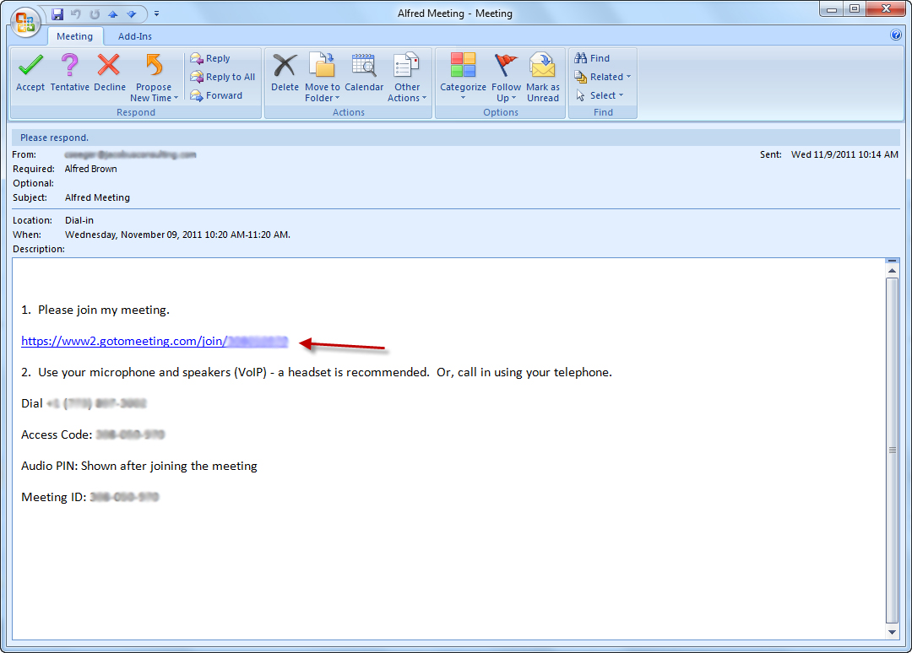
Figure 1
Click the link. Alternatively, you can go to www.gotomeeting.com, click on “Join a Meeting” and enter the Meeting ID in the email.

You will be redirected to a web page where you can download the software (Figure 2).
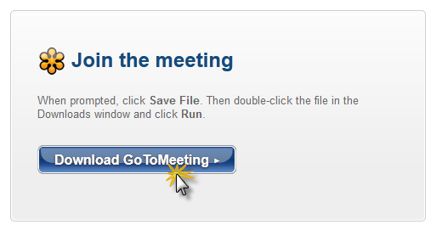
Figure 2
Once the download is complete, enter your name and email address and click “OK” (Figure 3).
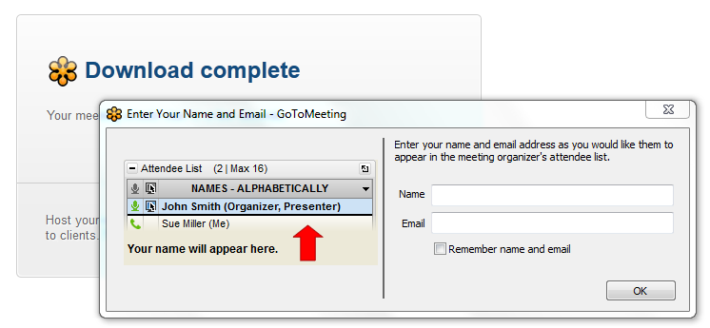
Figure 3
You are now using the software (Figure 4). If you have a microphone and speakers you can click the button next to “Mic & Speakers” (Figure 5). If you are using a telephone to connect, select “Telephone” and call the number provided; be sure to enter the Audio PIN.
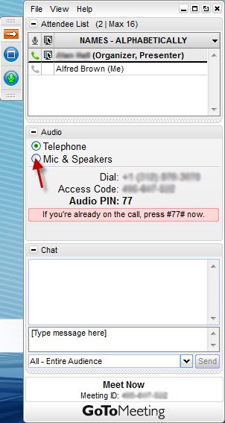  Figure 4 | 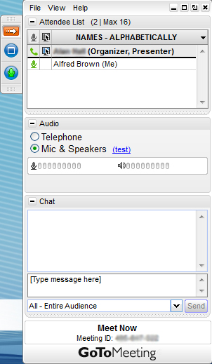  Figure 5

It is highly recommended that you mute when listening; feedback and background noise are often problems. To mute, click the green icon next to your name (Figure 6). Click on it again to un-mute. At the conclusion of the meeting, you can exit by going to “File” and then “Exit - Leave Meeting” (Figure 7).
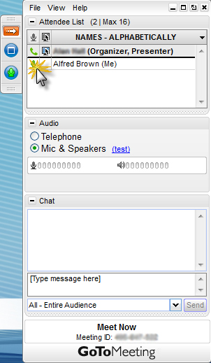  Figure 6 | 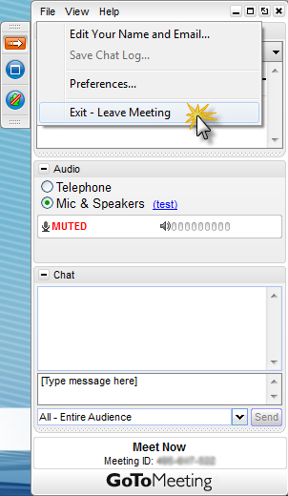  Figure 7

GoToMeeting Organizer
This section will detail how to organize a GoToMeeting session.

If You Have a Receptionist
If you have a receptionist who sets up meetings and you are the organizer for the meeting, you will send that person an email with:
- Date and time of meeting
- Duration
- Meeting title (e.g. “Summer Renewal Meeting”)
- Names and email addresses of attendees
The receptionist will send you back an email with a username and password and a link to the meeting. Click on the link. You may have to download the software (Figure 2). After this, or if you have already downloaded the software, you will see a message “Waiting for Organizer” (Figure 8). Click “log in.” Use the username and password given by the receptionist.
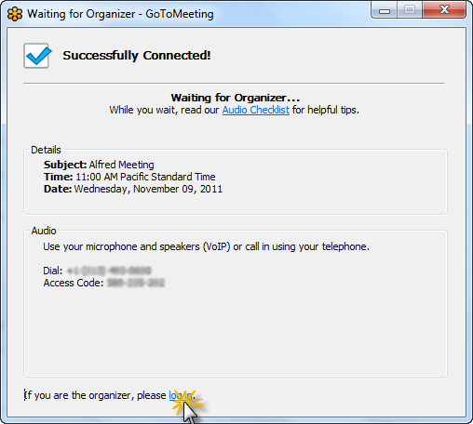
Figure 8

If You Do Not Have a Receptionist
If you do not have a receptionist and you are the organizer for a meeting, there are two ways to set one up. One is by going through the website; the other is through the GoToMeeting application. This will show you how to do it through the website. Go to www.gotomeeting.com and click “Host a Meeting” (Figure 9).
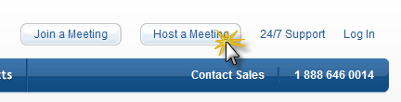
Figure 9

It will ask you to install the software, if you haven’t before. Then it will ask for your email address and password. Enter your own email address and password if you have a personal account with GoToMeeting. If you are using a company account, enter that email address and password. Then it will ask you if you want to “Meet Now” or “Schedule a Meeting” (Figure 10). We will schedule a meeting.
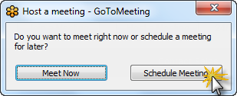
Figure 10
When you do, you’ll be presented with this screen (Figure 11). For subject, give a title for the meeting. Then schedule the date and beginning and ending times for the meeting. Offer both types of audio for greatest connectivity for people joining you.
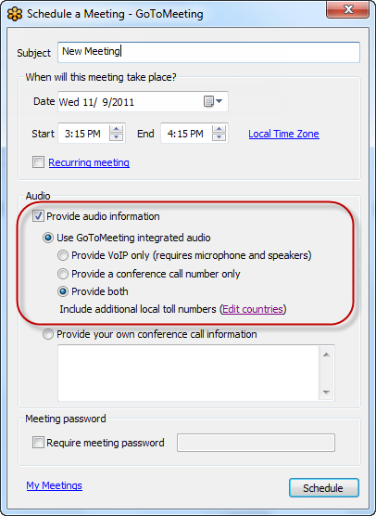
Figure 11
Once you click “Schedule,” if you have Microsoft Outlook, it will open a message for you (Figure 12). Enter the email addresses of the people you’d like to join your meeting. If you do not have Outlook, you will have an option to copy and paste the information into another email client. Send that message to whomever you wish to join the meeting.
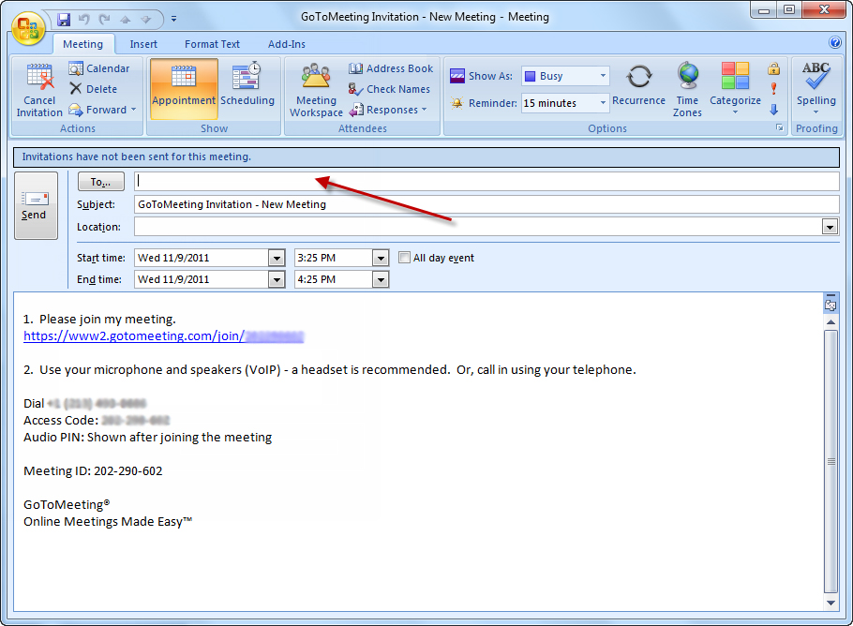
Figure 12

Presenting the Meeting
Your control panel will look something like this (Figure 13). Note the section on top. With these icons you can choose to start or stop showing your screen, give control of keyboard and mouse, and change presenter. Changing presenter means that another attendee will have their screen available for viewing.
When you log in, if you used an email and password other than your own personal account, your name will likely appear as that of the owner of the account. To change this, click “File” and then “Preferences” (Figure 14).
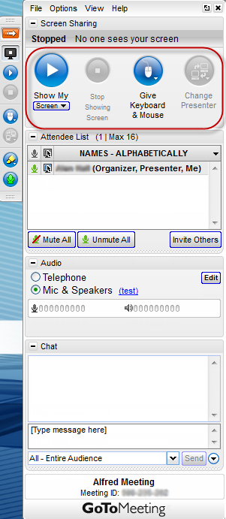  Figure 13 | 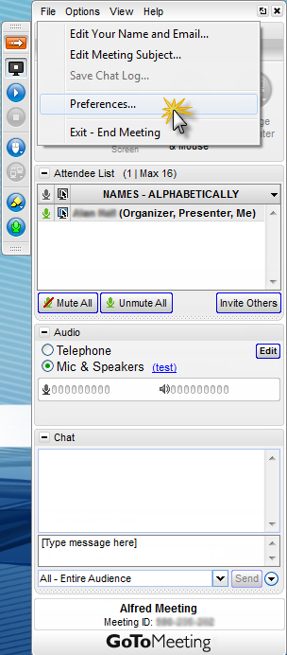  Figure 14
In “Preferences,” click “General” and then enter your name and email as you’d like it to be seen (Figure 15). Click “OK.”
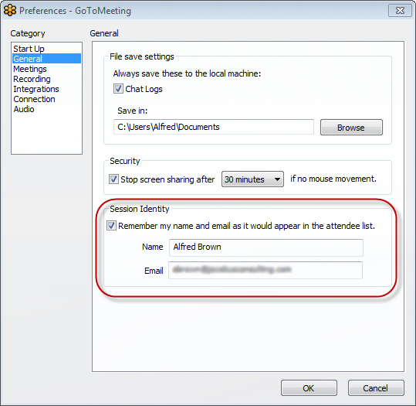
Figure 15
Click the play button above “Show My Screen” to start showing your screen (Figure 16). If there is feedback you can click on the green icons next to attendees names to mute them (unless someone is attending by telephone and has not entered the Audio PIN) (Figure 17). If an attendee has not entered the Audio PIN and they are causing feedback, then the only way to stop it is to mute everyone with the Mute All button, or right click the attendee’s name and send the Audio PIN to them to enter on the telephone. When you are finished, go to “File,” “Exit - Leave Meeting” (Figure 7).
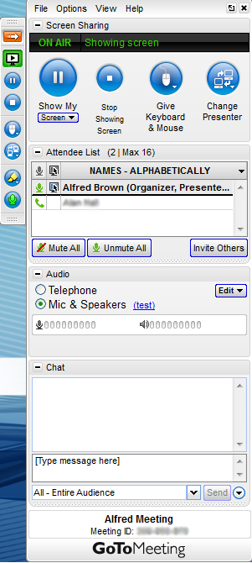  Figure 16 | 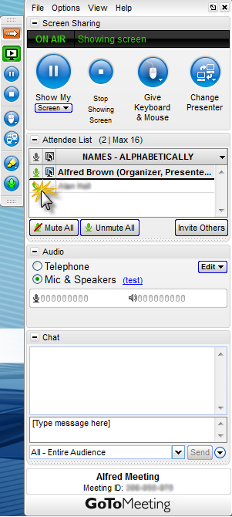  Figure 17

